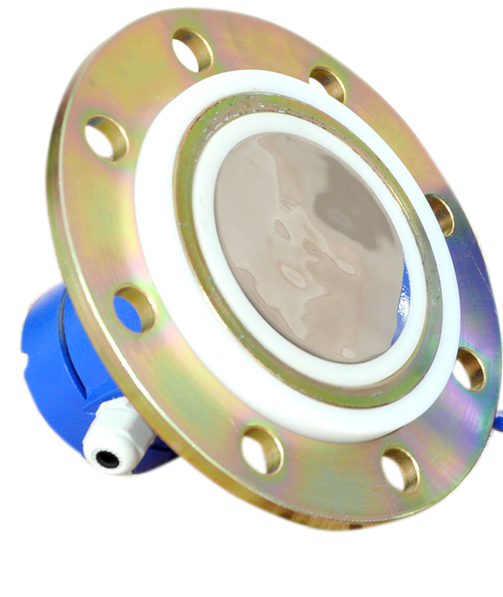
RF Admittance type level switch is a simple, low cost, rugged point Level Switch designed for Level detection of Bulk materials in a bins or silo. This level switch can be used for detecting high, low level or for differential level detection and is used in various level detection applications like. cement industries, material handling plants, chemical industry, power utilities industry, food industry, pulp/paper industry, pharmaceuticals industry, water/ treatment plants, foundry industry etc.
The specialty of the probe is that it tends to ignore the build-up on the probe, thus making it suitable for application, which tends to stick on the probe.
The unit shown above is integral Type Disc Probe along with time delay feature, LED indication, fail safe mode etc.
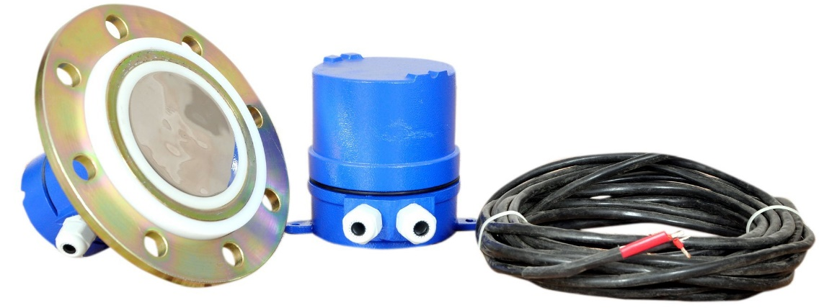
Unit Shown Below is Remote type Disc Probe along with time delay feature, LED indication, fail safe mode etc.
:

SALIENT FEATURES
- Easy installation and maintenance , Wide range of application
- Weatherproof/Flameproof enclosure as per requirement
- Sturdy electrode to withstand impact due to accidental clinker formation. UHMWPE insulated electrode works upto 80°C
- No moving parts, no mechanical wear and tear.
- Adjustable differential time delay with ON/OFF timing.
- Fail Safe High/Low Selection Feature (Field configurable)

Model: RFLS-300SD
Make: Levtron Instruments Pvt Ltd. Pune
SUPPLY VOLTAGE | 230VAC or 110VAC or 24V DC (factory selectable)
OUTPUT TYPE | 1 DPDT Relay
CONTACT RATING | 05 AMPS at 230VAC /24VDC, Resistive load Dual,
CABLE ENTRY | “PG 16, etc.
TEMPERATURE | 0-80°C for integral type.
 | 0-180°C with PTFE insulation and Remote type
PROBE | Type: Rigid Probe with Coat guard electrode Insulation:
 | UHMWPE / Teflon (for medium high temperature)
 | Probe Length: As per requirement, Housing: Cast Al.
MATERIALS | Probes (Sense SS304/SS316), Shield: CS, Flange/Adapter: /C.S/ SS316/SS304.
MOUNTING | Flanged process connection as per specifications.
Housing | Weatherproof as per IP 66 Flameproof (optional)
FREQUENCY | 120 KHz (±10%)
TIME DELAY | 0 To 30 seconds adjustable With ON/OFF delay Selection
FAIL SAFE | Selectable.
Technical Specifications
Before to Order, please confirm below Details,
- Process Parameters: Temperature, pressure,
- atmosphere: hazardous /non-hazardous.
- Application media, characteristics: Sp. Gr., Dielectric constant, hazardous or not, corrosiveness, viscosity.
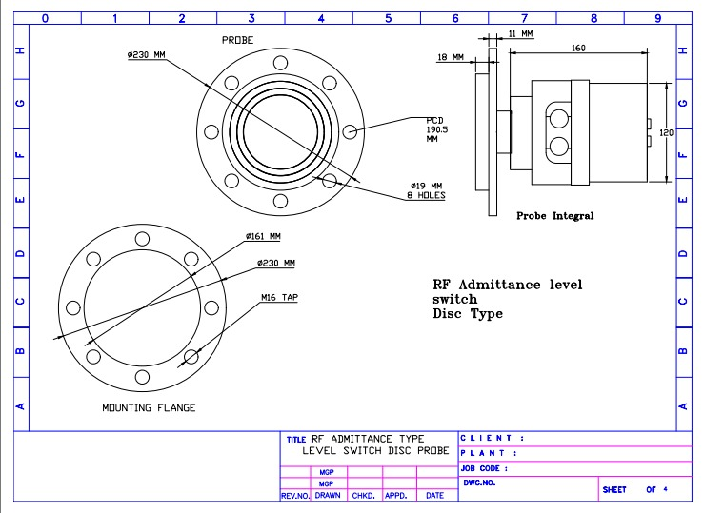
Mechanical Drawing: Integral Type
Mechanical Drawing: Remote Type

